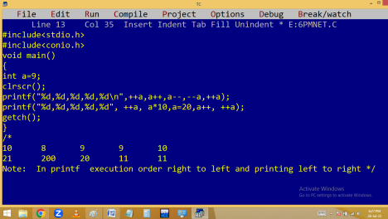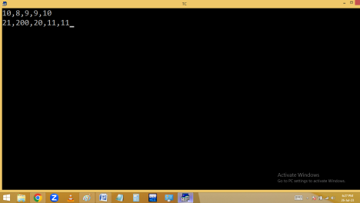
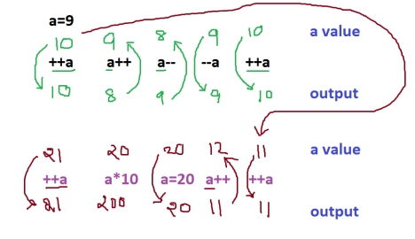
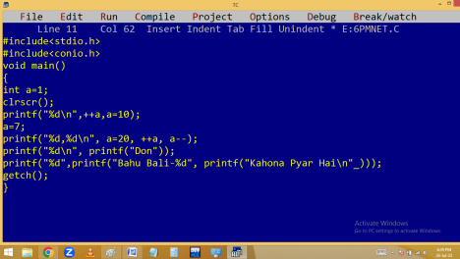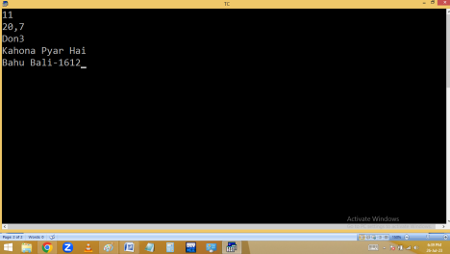
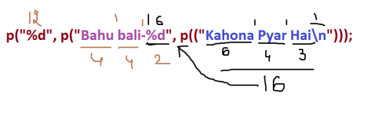
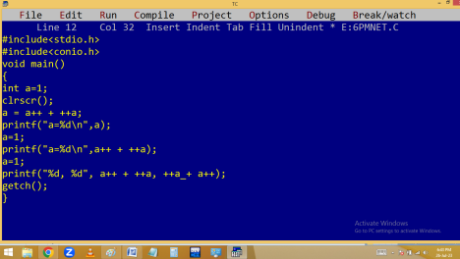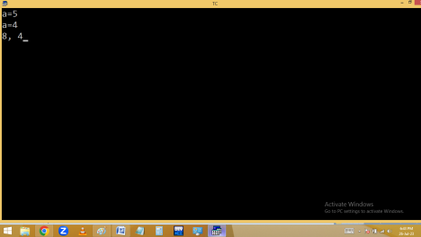
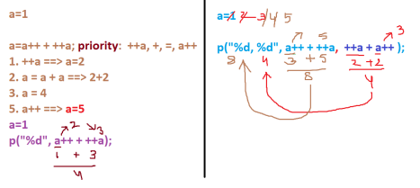
Compound assignment / short hand operator:
Here we are using one assignment operator with the combination of other operators as follows.
+=, -=, *=, %=, /=, ~=, <<=, >>=,….
Eg:
int a=25, b=10;
float c=5;
a+=7; i.e. a=a+7 🡺 25 + 7 🡺 a = 32
b*=4; i.e. b=b*4 🡺 10 * 4 🡺 b=40
c/=2; i.e. c=c/2 🡺 5/2 🡺 c=2.500000
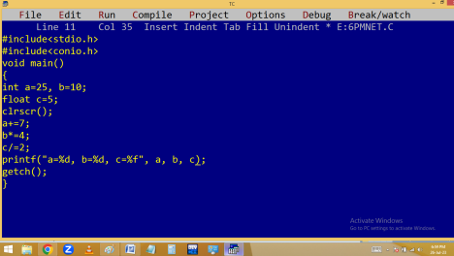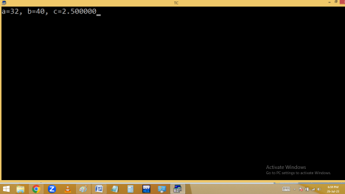
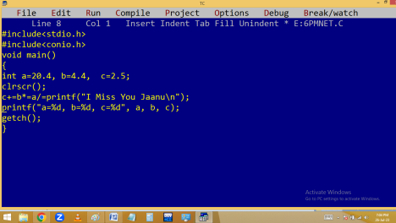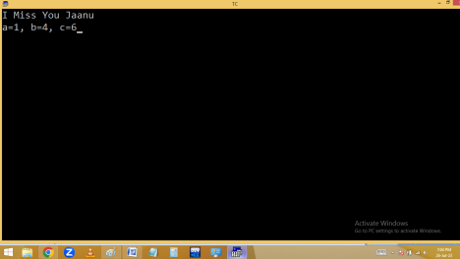
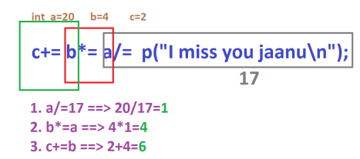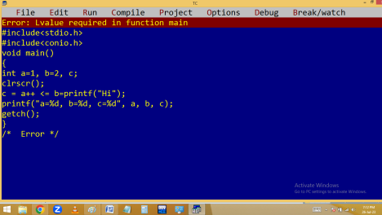
Address operators:
1.& - Address of variable
2. * - pointer – Address of another variable
( ) and , separators:

